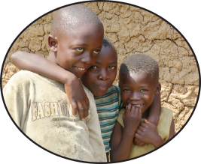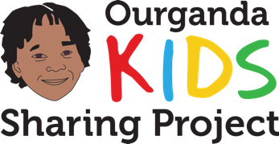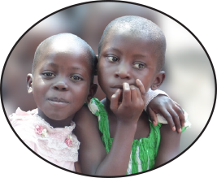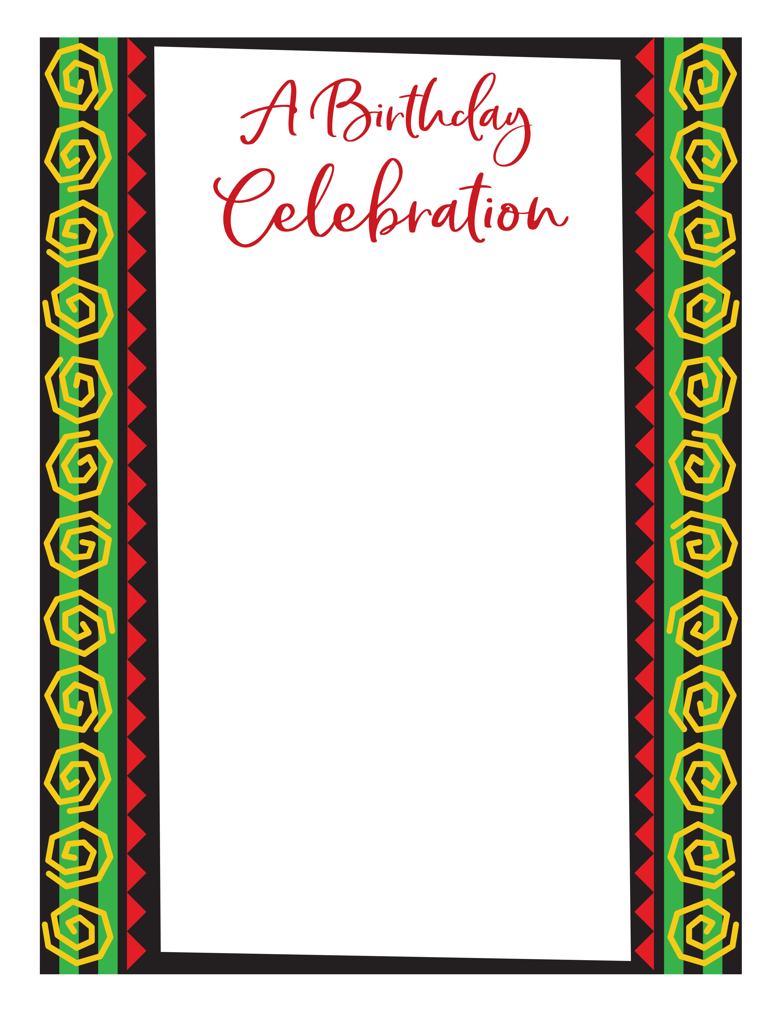

**Clara Is Turning 11!**

**Date**

**Time**

**Location**

**Address**

*Other details of the party go here   
i.e. bring a swim suit, party theme, etc.*

Clara has requested that instead of gifts,   
that you make a donation to the

*This wonderful nonprofit organization provides clean*

*water and medical care to children, their families,*

*and their communities in Uganda, Africa.*

**To make your donation, go to:**

**Ourganda.org/kids**

**Thank you for helping to**

**change lives**

**through your gift!**